**Lab # 03**

**Understanding and Familiarity with the Project Management Tool Using Project Libre**

**Objective:** The objective of this document is to help students gain an understanding and familiarity with **ProjectLibre**, a free and open-source project management software. The document introduces core project management concepts and demonstrates the practical implementation of Work Breakdown Structures (WBS), Gantt Charts, and Scheduling using **ProjectLibre.**

**Tasks**

1. Install and Set up Project Libre.

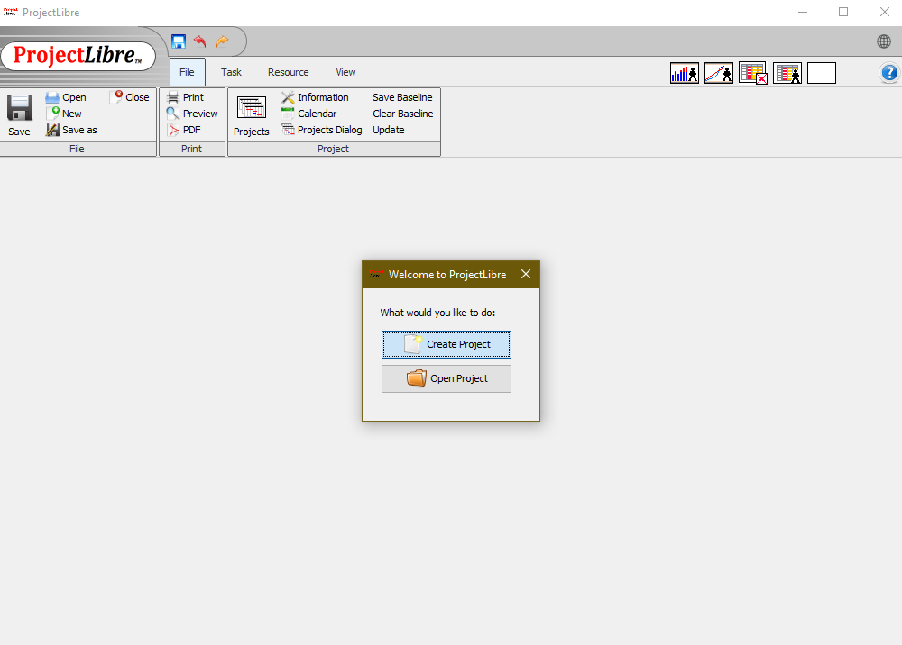

1. Create a new project named "**Student Management System** / **Student Portal**"

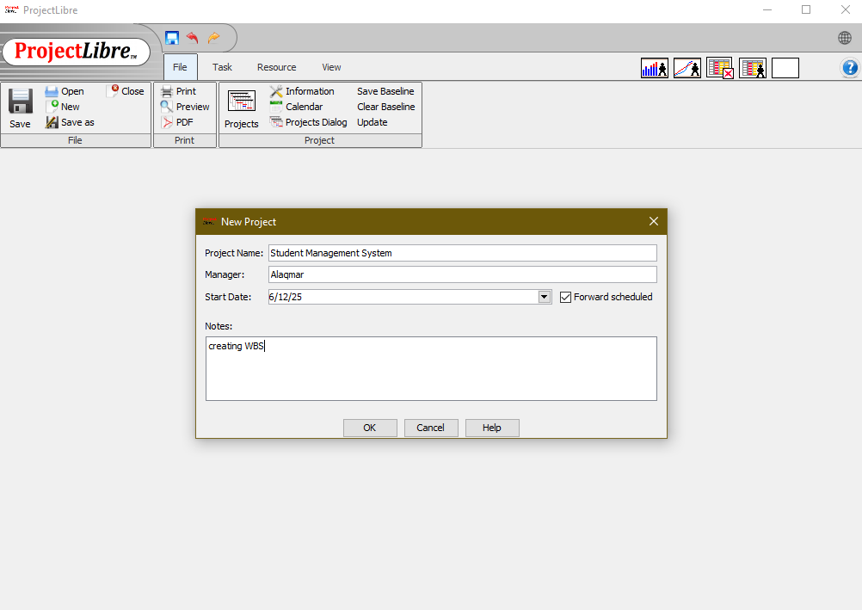

1. Enter at least 8 tasks and arrange them with dependencies.





1. Define the WBS structure for the project.

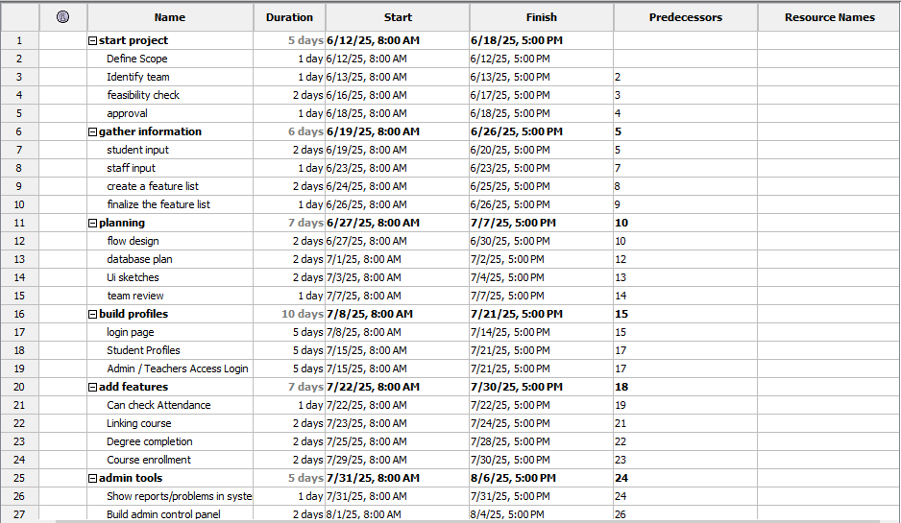

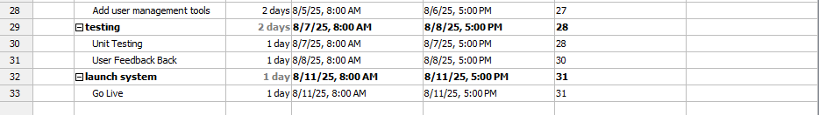

1. View and analyze the Gantt Chart.

